Windows Mobile Viewing Instructions
Copy the mobile phone monitor software to the phone (Use PC synchronization software or network download function).
Click the software and then follow the steps one by one to install the software mobile phone.
Or you can input the device IP address plus mss.cab in the browser address column. In this way, you can install the program to the mobile phone directly. For example, if your device IP is 10.7.74, then you can input http://10.7.4.47/mss.cab in the the browser. See Figure 2-1.
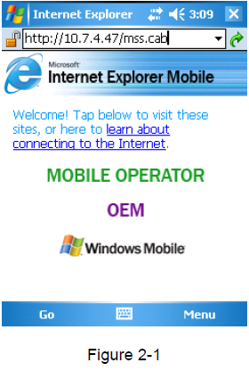
Then you can see an interface shown as in Figure 2-2. You can install the software now.
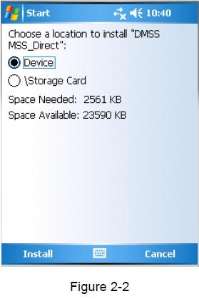
After the software installation, you can see the following interface. See Figure 2-3.
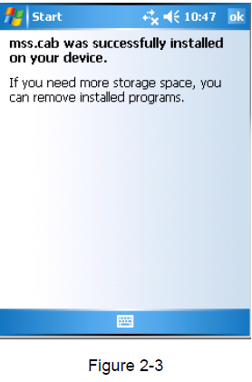
DVR Setup
Please set the connected DVR encode iformation to make the device suitable for the mobile phone monitor.

